**EMPLOYER BRANDING PRACTICES IN DIGITAL AREA**

** Journal of International Trade, Logistics and Law**

***Merve Temel***

Yildiz Technical University , Turkiye

***Emel Esen (Prof. Dr)***

Yildiz Technical University , Turkiye

**Abstract:**

Companies that aware of employees are the most important resource are developing employer branding practices that create a "best place to work” perception day by day. Today, social media platforms have become an important area for companies that want to increase the awareness of employer brands and reach large masses faster and more cost-effectively. This study aims to examine the practices of companies that reflect employer branding in the digital area. In the research, the accounts of 6 companies selected among the in Universum's research to determine the best employers in 2022 on Instagram, one of the most active platforms of social media, were examined; the posts were handled contextually and the practices reflecting the employer brand and the messages desired to be given were tried to be determined and the number of interactions were discussed. Content analysis method was used as the most appropriate method to determine the content of the companies' posts that reveal the employer brand and the practices discussed in these contents and to interpret the data obtained as a whole. Employee expectations identified in the "Employee Priorities and Preferences" research conducted by PwC in 2020, the employer brand dimensions (economic, interest-benefit, application, development, social-value, work-life balance and corporate social responsibility) identified within the scope of the research conducted by Berthon et al. in 2005 and Tanwar and Prasad in 2016 were analyzed and interpreted. In addition, when the posts are analyzed, it is seen that they can reach large audiences with likes, comments or views.**Key Words:** Employer Branding, Digitalization, Social Media, Employee Expectations

**Introduction:**

Employees are the most important resource of companies today. In today's competitive world, the ability to retain your talented employees and attract the potential candidates you want to reach is undoubtedly one of the most important steps in gaining a competitive advantage. Companies that are aware of this are trying to meet the employee expectations of the period and develop a perception of "the best place to work" with their vision, mission, culture and employer branding practices. Employer branding as a concept emerged in the 1990s during the so-called "war for talent" and during this period, employer branding was seen as a long-term alternative solution to the problem of inadequate quality of the workforce (Clarke, 2009, 33). In the changing understanding of brand over time, it is aimed to create a corporate identity on values, systems, policies and behaviors in order to create a space where current and potential employees will be influenced and to motivate them (Pogorzelski et al., 2010, 72). The three main benefits that the strengthening of the employer brand brings to companies can be listed as enhanced attractiveness, retention, and commitment (Mosley, 2009, 5). In Universum's Employer Branding Now 2022 research, employer branding is one of the most important priorities for 1650 leaders participating in the study. In 2021, the priority given to employer branding was 76%, while this rate increased to 86% in 2022 (Universum, 2022).

In recent years, with the increasing digitization, social media channels have become a crucial space for companies aiming to enhance the visibility of their employer brands, particularly to reach broader audiences faster and more cost-effectively. Especially as Generation Y, which is more tech-savvy than the previous generation, takes on leadership roles and Generation Z, which was born into the internet age, enters the workforce, traditional channels are becoming less relevant for companies. The visible aspect of the future is digitization and machines, whereas the invisible aspect is, in fact, human. The human, who is the focal point of work, is becoming an even more critical resource (Küçükgökdemir and Bal, 2018, 1995). Companies have now extended their employer branding practices to digital platforms, targeting employees who possess new skills, readily adapt to rapid changes, live in harmony with technology and are comparatively more challenging to retain than previous generations. According to the 2021 research conducted by Jobvite Recruiter Nation, the largest investments made by employers in developing employer branding are in social media, accounting for 63% (Jobvite, 2021).

This study aims to examine the practices of companies reflecting their employer branding in the digital environment. In the research, the accounts of companies on Instagram, one of the most active platforms of social media, were examined; the posts were analyzed contextually, aiming to identify practices that reflect the employer brand and convey intended messages, while also examining the number of interactions. Despite the abundance of studies investigating the practices of companies reflecting their employer branding, there is a scarcity of research specifically addressing the digital reflection of these practices. Therefore, this study is expected to contribute to the literature in this regard. Especially in today's business environment, the influence of social media in communicating with the new workforce, particularly Generation Z, is widely recognized.

**1. LITERATURE REVIEW**

**1.1. Employer Branding**

The concept of brand is defined as a special name or symbol that serves to introduce and distinguish a commercial product or any object (Turkish Language Association, 2022). With the increasing importance of human resources for companies, the efforts of companies to develop their brands have evolved beyond just differentiating their products to gain and satisfy customers. It has turned into an effort to establish a corporate identity. Additionally, the idea that organizations and individuals can also become brands has emerged as a result of changes in business life. Therefore, the branding process has developed to encompass not only influencing and acquiring customers but also extending to both companies and their employees (Kuşçu & Okan, 2010, 121). Moreover, when the conducted studies are examined, it is observed that employer branding is closely related to strategic management and behaviors (Wojtaszyk, 2012, 47).

The initial exploration of the employer branding concept and the studies initiated by Ambler and Barrow began to form the conceptual framework of employer branding. Companies' efforts to gain identity and brand as employers, enhance the image in the eyes of talented employees and potential candidates, and increase employee loyalty started to gain importance. Ambler and Barrow (1996, 187) characterize employer branding as a set of economic, functional, and psychological benefits that employers offer to employees. These benefits include economic conditions such as salary and fringe benefits, functional aspects like working conditions, work-life balance, flexible working hours, and opportunities for education, as well as psychological factors such as motivation, respect, and reputation gained by employees. The conceptual effort to explain employer branding, initiated by Ambler and Barrow, has continued until today. The common point in all these concepts lies in the desire of companies to be "the best place to work" by creating an impact on the emotions and thoughts of employees through employer branding. Employer branding has emerged and gained importance through the application of marketing and branding strategies in human resources practices (Fasih et al., 2019, 83). Employer branding provides an opportunity for the employer to communicate and instill messages supported by the company's mission and vision to employees (Kuşçu & Okan, 2010, 122).

The perception of an organization as a more attractive employer by its employees contributes to further strengthening the organization's brand value (Berthon et al., 2005, 158). A strong employer brand attracts more talented candidates to the company and shapes their expectations regarding their futures and employment (Lievens & Highhouse, 2003, 79). In this way, companies can reach successful candidates more easily, reduce recruitment costs, establish stronger relationships with employees through their employer brands, and increase employee loyalty and retention rates. Companies with a strong employer brand even gain an advantage in making lower salary offers and achieving higher acceptance rates compared to weaker brands (Ritson, 2002, 24). In addition to providing benefits to current employees and potential candidates, employer branding is critically important for enhancing a company's competitive position in other areas of the market (Figurska & Matuska, 2013, 40-41). Employer branding motivates employees to improve the quality of the products and services they offer (Chunping & Xi, 2011, 2088). With all these advantages, companies gain a significant competitive advantage in the market environment they operate in.

**1.2. Digitalization and Social Media**

The concept of digitization was first used by Robert Wachal in 1971 in the North American Review journal. Wachal explained the concept by addressing its societal impacts and consequences, such as cultural and demographic aspects, in his discussion (Savic, 2020, 30). Subsequently, perspectives on digitization have diversified over time, leading to an increase in research in this field. In short, digitization is defined as the intelligent connection of people, objects, and technologies (Keskin, 2018, 2). The adoption of digital technologies involves not only eliminating paper and its derivatives from our lives and reducing manual effort but also generating value by harmonizing solutions and systems reached through the management and organization of digital data and minimizing manual processes (Parida, 2018, 24). It establishes connections between "people-objects" and the "real-digital" worlds, creating new values and, as a result, developing effective and efficient ways to solve societal problems, offering a better life for people and promoting sustainable economic growth (Fukuyama, 2018, 47). Digitization has not only changed production processes but also transformed organizations and business models with new digital technologies (Klein, 2020, 25-26). It reshapes how work is done, creating value within the company and brings about changes in the corporate culture (Agarwal et al., 2011, 634).

The most significant digital innovation that marked the 20th century was the advent and widespread use of the internet. With the increase in globalization, communication has become the most crucial concern for societies, countries, and companies. Social media, a virtual communication platform, has become an integral part of our lives, widely preferred by large audiences globally and further intertwined with digital innovations. Social media is an interactive space that enables the sharing of different perspectives, thoughts, and experiences (Weinberg, 2009, 1). According to the Social Digital 2023 report, there are 4.80 billion social media users worldwide, which accounts for slightly less than 60% of the total global population. In Turkey, the active social media user rate based on the population is 73.1%. Among users in the age group of 16 to 64, 24.3% use social media for business-related networking or information sharing (We Are Social, 2023). Social media is not only for individuals but has also become a preferred space for companies today to communicate with their customers and employees. With the development of Web 2.0, companies have rapidly embraced the use of social media, especially in response to the impact of consumers who can generate information and content, created by social media (Berthon et al., 2012, 261). Companies that have successfully overcome this situation by actively using social media in a short period generally use social media platforms to inform the public and disseminate educational messages, manage discussions, explain themselves in the face of mistakes or shortcomings, and garner support for personal and societal events (Jury, 2014, 34). Especially with the recognition of the impact created by information shared through social media, the priority for companies has shifted towards building a strong corporate image. Companies aim to increase the loyalty of current employees to the organization and attract potential candidates by establishing a robust corporate image (Parry & Solidoro, 2013, 128). The relationship between social media and employer branding can be summarized briefly as follows (Labrovic et al., 2021, 71):

Figure 1: Employer Branding & Social Media

Employer Attraction (Employer of choice)

S

O

C

I

A

L

M

E

D

I

A

Employer Image

Employer Brand Association

External Employer Branding

Employer Branding

EmployeeSatisfaction & Engagement & Productivity

Employer Brand Loyalty

Organinizational identity

Organizational culture

Internal Employer Branding

Source: Labrovic vd., 2021,71

In this regard, social media eliminates the boundary between large and small companies, creating equality and, when used correctly and effectively, providing small-scale companies with a competitive opportunity. Additionally, it is crucial for companies to observe their competitors in the competitive environment they are in, gather information about the practices and successes of other companies. The potential gains obtained through social media are an issue that cannot be overlooked (Kaplan & Haenlein, 2010, 67).

**2.RESEARCH METHODOLOGY**

**2.1. The Purpose and Method of the Research**

In this research, it was tried to examine the posts made by companies on the Instagram platform regarding their employer brands, and it was aimed to create a general picture of the Instagram content of the companies ranked in the Universum research and to identify the practices that reveal the employer brand. Instagram, which is based on photo and video sharing, has a wide user base with its applications that are differentiating day by day around the world. Instagram is preferred by employees and potential candidates because it is one of the most used social platforms and are also a platform that is in great demand by companies to develop their employer brand. The employer brand dimensions (economic dimension, interest-benefit dimension, application dimension, development dimension, social-value dimension, work-life balance dimension, and corporate social responsibility dimension) identified by Berthon et al. (2005, 156-167) and Tanwar and Prasad (2016, 196) were preferred within the scope of the research. In order to comprehensively perceive and interpret the posts revealing the employer brand on companies' Instagram platforms, the qualitative research method has been chosen. Qualitative research is an approach that aims to investigate social phenomena in a realistic and holistic way in a natural environment with an understanding that aims to create theory, using qualitative data collection techniques such as observation, interview and document analysis (Yıldırım and Şimşek, 2008, 39). Additionally, content analysis facilitates the visibility of messages that may not be immediately apparent (Neuman, 2017, 468).

**2.2. Assumptions of the Study**

In this study, it is assumed that the selected companies, chosen among those identified by the votes of business department students worldwide in the Universum World’s Most Attractive Employers 2022 survey, exhibit employer brand practices on Instagram that align with the identified dimensions of the employer brand.

The sample of the study consisted of 6 companies selected from the 50 companies identified by the votes of business students in the Universum World’s Most Attractive Employers 2022 survey, representing three different sectors. The Instagram content of these selected companies was assumed to be in line with the employer brand dimensions. Additionally, it was assumed that sufficient data for the research could be obtained by examining all content covering the years 2022 and prior, from the latest post of the selected companies to their first post.

**2.3. Sample of the Study**

The population of the study consists of the 50 companies identified through the votes of business students in the Universum World’s Most Attractive Employers 2022 survey. The sample of the study is composed of 6 companies selected from the results of the Universum World’s Most Attractive Employers 2022 survey. These companies are HSBC, Allianz, Pepsico, Nestle, P&G, and Unilever. The selected companies were chosen from three different sectors without consideration of their size, number of employees, or revenue. Factors such as being among the most preferred sectors to work in, being frequently chosen to work in their respective sectors, operating globally, frequently receiving awards in the dimensions we examined, active usage of Instagram, and having a high number of followers were taken into account.

Table 1. Demographics of the Sample

|  |  |  |  |  |  |
| --- | --- | --- | --- | --- | --- |
| **Company Name** | **Foundation Years** | **Sector** | **Number of Followers** | **Years of the First Post** | **Number of post** |
| **HSBC** | 1865 | Finance | 15,3B | 2019 | 168 |
| **ALLIANZ** | 1890 | Finance | 17,5 B | 2016 | 1.275 |
| **NESTLE** | 1866 | FMCG | 17,2B | 2019 | 945 |
| **PEPSICO** | 1965 | FMCG | 51,5B | 2018 | 654 |
| **UNILEVER** | 1929 | Production | 58,4B | 2017 | 528 |
| **P&G** | 1837 | Production | 191B | 2012 | 1.650 |

**2.4. Data Analysis**

As the data collection method, the content analysis method was selected to examine the employer brands in the Instagram posts of the companies identified as the sample. Information about the 6 global companies forming the sample of the study was accessed through each company's official website. The content analysis of the posts from the career & life pages on the Instagram platform, covering the years 2022 and earlier, was conducted in four stages. In the first stage, the dimensions of the employer brand to be used for the study were determined. In this study, the 7 dimensions identified by Berthon et al. (2005, 156-167) and Tanwar and Prasad (2016, 196) were utilized. These dimensions are Economic Dimension, Social Value Dimension, Application Dimension, Interest-Value Dimension, Development Dimension, Corporate Social Responsibility Dimension, and Work-Life Balance Dimension. Additionally, the employee expectations emerging from the PwC Employee Priorities and Preferences 2020 Survey were categorized under these dimensions. In PwC's study, while employee expectations overlapped with six of the seven dimensions identified by Berthon et al. (2005, 156-167) and Tanwar and Prasad (2016, 196), no classification could be made under the Corporate Social Responsibility dimension. However, the fact that social responsibility projects are frequently included in the analyzed accounts led to the inclusion of the Corporate Social Responsibility dimension in the study.

Table 2. Categorization of Employee Expectations Under Dimensions

|  |  |  |  |  |  |  |
| --- | --- | --- | --- | --- | --- | --- |
| **Economic**  **Dimension** | **Social Value**  **Dimension** | **Interest Value Dimension** | **Appl.**  **Dimension** | **Develop.**  **Dimension** | **Work-Life Balance**  **Dimension** | **Corp. Social Respons.**  **Dimension** |
| Base salary and bonuses  Reliable and fair performance-based promotion and compensation system  Promotion speed  Career opportunities  Overtime pay  Flexibility in benefits  Retirement income | Team members  Accessible and trustworthy leaders  Teamwork and collaboration  Developing social skills  Open and honest leadership comm.  Inclusivity and diversity | Interesting and challenging tasks  Sharing ideas to promote innovation  Job diversity | Awareness of the company's products and services | Job-specific/technical training  Advanced academic education  Developing the manager's leadership style  Enhancing digital skills  Coaching/mentoring programs | Flexible working hours and schedule  Predictability of working hours  Protective health services and health aids  Remote work  Work environment that promotes well-being | - |

Source: PwC (2020). Çalışan Öncelikleri ve Tercihleri Survey. (26.08.2022) https://www.pwc.com.tr/pwc-calisan-oncelikleri-ve-tercihleri-arastirma-raporu/

In the second stage, expressions assumed to reveal the dimensions of the employer brand based on these analyses were identified and placed in tables. Additionally, screenshots of content deemed important for reflecting the employer brand were added to the findings section. The tables and findings resulting from the analysis were organized and reviewed in collaboration with the advisor. In the third stage, all findings generated for the analysis were examined to identify themes reflecting the employer brand. In the fourth stage, practices reflecting the employer brand were identified, organized based on the conducted analyses and tables, and finally, the obtained findings were defined, assessed, and interpreted.

**Findings:**

In the study, the employer brand dimensions used, along with the practices mentioned in the Instagram posts of each company in the sample, addressing their employer brands, were interpreted and evaluated through direct quotations. The emerging evaluations are expected to strengthen companies' employer brands, increase their visibility, and enhance communication with employees or potential candidates. The examinations and assessments conducted within the scope of content analysis have led to the following results.

As of the examined date, P&G is the company with the highest number of posts and followers, while HSBC has the fewest posts and followers. The correlation between the number of posts and followers appears coincidental, and upon examining other companies, a proportional relationship between the number of followers and the number of posts could not be established.

Figure 1: proctergamble Figure 2: lifeathsbc

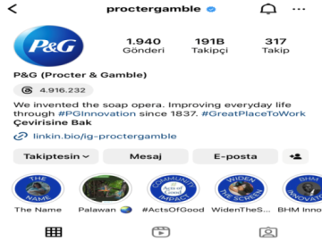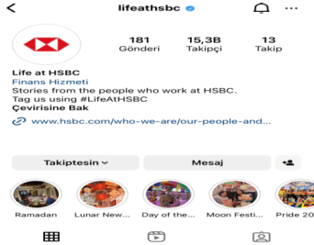

When comparing the initial posts with the current ones, it is observed that professionalism has increased, and more purpose-oriented posts are being made in today's context. When examining the practices reflected in the Instagram profiles of the companies,

it is observed that each of them has numerous practices that can be categorized under the identified dimensions. While these practices often exhibit differences, occasional similarities are also observed. The most similar reflected practices are coaching & mentoring support under the development dimension and hybrid & flexible working programs under the work-life balance dimension.

Figure 3: P&G Work-Life Balance Dimension

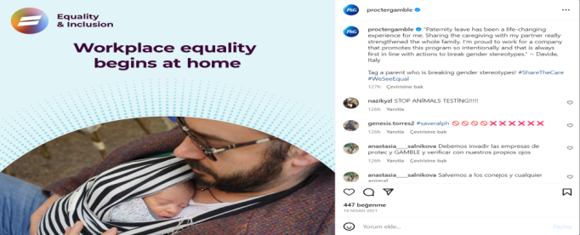

Fignure 4: Nestle Work-Life Balance Dimension

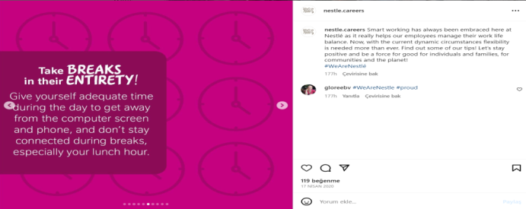

The innovative ideas and initiatives that companies address under the interest-value dimension are seen as the most diverse area.

Figure 5: Pepsico Interest Value Dimension

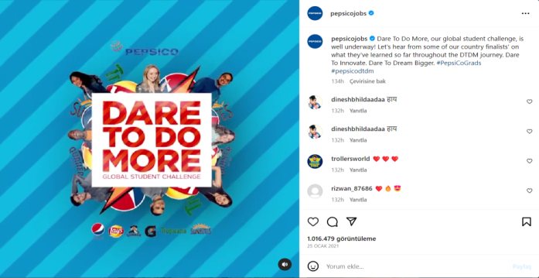

Figure 6: Allianz Interest Value Dimension

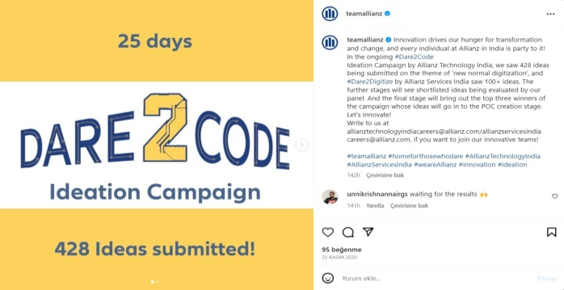

The dimension with the least number of posts by companies is the application dimension. Salary packages, allowances, bonuses, and other compensation details under the economic dimension are kept confidential for each company, while an emphasis is placed on

the fairness and equality of the compensation system, aiming to build trust in the perception of economic aspects for the viewers. Furthermore, companies often strive to gain the approval and admiration of society by sharing nearly every activity that benefits the community and humanity, such as environmental initiatives, sustainability, and projects for community development and empowerment on their Instagram profiles. It is observed that in many social responsibility projects, companies take care to involve their employees, aiming to provide social responsibility satisfaction to both their employees and potential candidates.

Figure 7: Allianz Corparate Social Respons. Dimension

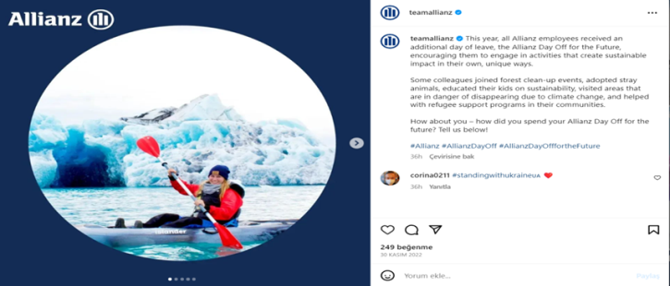

Figure 8: Unilever Corparate Social Respons. Dimension

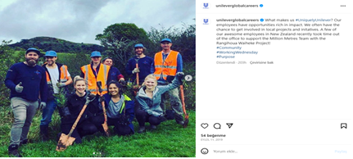

Each company strives to convey the uniqueness and distinctiveness of its desired employer brand strength and culture through its posts, creating a distinct impression for the viewer. The differentiation is achieved through the uniqueness of shared practices, the content of the posts, color details used in the content, and the visual/video formats. For instance, HSBC receives the highest engagement in posts that feature long-term employment for its employees, while P&G and Pepsico gain more interaction in posts related to innovation. Unilever and Nestle achieve the most interaction through their internship and job programs for students and recent graduates. Allianz increases interaction with posts related to social and community activities such as LGBT initiatives and Disability Awareness Day compared to other content.

Figure 9: HSBC Economic Dimension

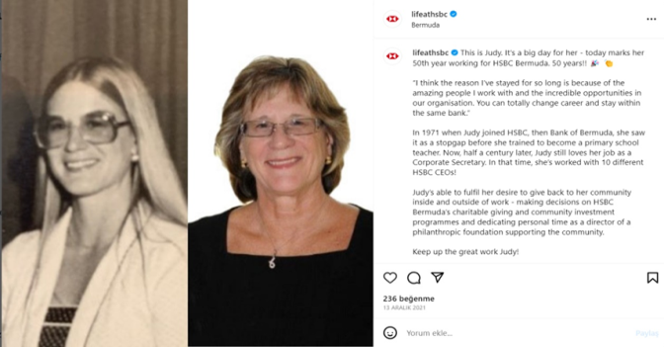

Furthermore, when examining the interactions with the posts, it is observed that the topics with the highest likes/views for each company are different. This suggests that the intended message is effectively communicated, and different details about the companies stand out in the perceptions of the viewers.

Figure 10: Unilever Economic Dimension

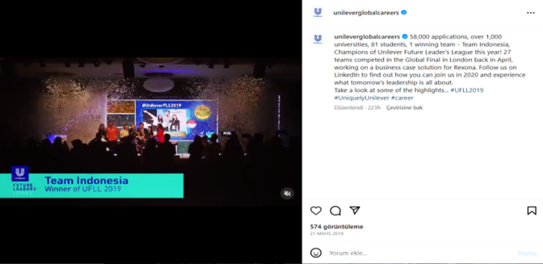

When looking at the likes and interaction numbers of the shared posts, it is observed that the average likes for photo and video content posts fall between 0 and 250 likes. For instance, P&G has become the company receiving the most likes, averaging 407 likes for its photo content posts, while PepsiCo achieved the highest engagement with an average of 440 likes for its video content posts. Even when the likes on posts are relatively low, examining the video view counts reveals that some posts from companies have reached millions of views, with an average video view count of over 1000+. Unilever has the lowest engagement with an average of 756 views for its video content posts, while PepsiCo has the highest engagement with an average of 9,761 views for its video content posts.

When looking at the likes and comment interactions on the companies' posts, it is observed that posts with the highest interactions generally include activities that increase the recognition of employees or social activities such as social responsibility, innovation projects, and various events involving employees. Additionally, posts introducing offices and workspaces also receive high interactions. In contrast, posts that do not feature real spaces or individuals receive significantly lower interactions.

**Conclusion:**

The increasing number of companies in the competitive business environment highlights the significance of companies not only making their products and services unique in their respective sectors but also having a talented workforce as a crucial strength. Companies offering functional, economic, and psychological support to their current employees not only contribute to retaining their workforce and ensuring that employees come to work happy and motivated every day but also create a perception of enthusiasm and desire among potential candidates to work for these companies. The changing demographic structures of companies have significantly altered employee expectations as well.

In today's world, one of the communication channels preferred by companies to amplify the strength of their employer brands is social media. Through social media platforms, companies can announce their practices, establish deep relationships with their employees, and rapidly reach potential candidates they aim to target. Furthermore, companies often share almost every activity that benefits society and humanity, such as environmental initiatives, sustainability projects, and initiatives for community development and empowerment, on their Instagram profiles to gain the approval and admiration of society. This allows companies to increase their visibility and facilitate conveying the desired message, thus enhancing their employer brand strength. When looking at the number of followers, likes, and video views of companies, it is evident that both current employees and potential candidates prefer using social media platforms to follow and gather information about companies. When looking at the likes and comment interactions on the companies' posts, It is assumed that employees and potential candidates are more likely to support posts that genuinely reflect the company culture, employee and workplace profiles, and employer brand, rather than artificial and unrealistic posts that only showcase the agency's work.

In this study, it is assumed that each dimension used to measure the employer brand supports and strengthens the companies' employer brands. The criteria reflected by the companies on social media platforms, as examined within the determined dimensions, contribute to shaping the internal dynamics of their employer brands. Through these dimensions containing the criteria, the employer brand strengths reflected by the companies on social media platforms and the outcomes obtained have been measured. In this context, it has been concluded that all the companies in the sample have an employer brand, but the practices they prefer to reflect on social media platforms vary from company to company. This variation not only adds uniqueness to the companies but also creates a strong perception of different dimensions.

**References:**

Agarwal, R., Johnson, S. L., & Lucas, H. C. (2011). Leadership in the face of technological discontinuities: the transformation of EarthColor. Communications of the Association for Information Systems, 29(1), 33

Allianz. (17.07.2023). About Us. https://www.allianz.com/en/about-us.html

Allianz. (27.09.2023). teamallianz. https://www.instagram.com/teamallianz/

Ambler, T., & Barrow, S. (1996). The employer brand. Journal of brand management, 4, 185-206.

Berthon, P., Ewing, M., & Hah, L. L. (2005). Captivating company: dimensions of attractiveness in employer branding. International journal of advertising, 24(2), 151-172.

Berthon, P. R., Pitt, L. F., Plangger, K., & Shapiro, D. (2012). Marketing meets Web 2.0, social media, and creative consumers: Implications for international marketing strategy. Business horizons, 55(3), 261-271.

Clarke, R. (2009). How to maintain the employer brand. People Management Journal, 33.

Chunping, Y., & Xi, L. (2011). The study on employer brand strategy in private enterprises from the perspective of human resource management. Energy Procedia, 5, 2087-2091.

Figurska, I. ve Matuska, E. (2013). Employer Branding As A Human Resources Management Strategy. Human Recources Management andErgonomics, 7(2), 35-51.

Fukuyama, M. (2018). Society 5.0: Aiming for a new human-centered society. Japan Spotlight, 27(5), 47-50.

HSBC. (17.07.2023). Who We Are?. https://www.hsbc.com/who-we-are/our-history

HSBC. (27.09.2023). @lifeathsbc. (https://www.instagram.com/lifeathsbc/ )

Jalees, T., & Mateen Khan, M. (2019). Antecedents to employer branding. Fasih, ST, Jalees, T., & Khan, MM,(2019). Antecedents to employer branding. Market Forces, 14(1), 81-106.

Jobvite (2021) Jobvite Recruiter Nation Survey, (15.02.2023) https://www.jobvite.com/lp/2021-recruiter-nation-report/

Jury, T. A. (2014). A crisis of reputation in a Social Media environment: a comparative analysis of the crisis communication strategies employed by Jetstar and Air New Zealand in a severe weather event (Doctoral dissertation, Auckland University of Technology).Kaplan, A. M., & Haenlein, M. (2010). Users of the world, unite! The challenges and opportunities of Social Media. Business horizons, 53(1), 59-68.

Keskin, İ. (2018). Dijital dünyanın sesini duyabilenler

Klein, M. (2020). İşletmelerde dijital dönüşüm ve etmenleri. Journal of Business in The Digital Age, 3(1), 24-35

Kuşçu, A., & Okan, E. Y. (2010). An Exploratory Study On The Dimension Of Employer Branding-İşveren Markalaşmasının Boyutları Üzerine Keşifsel Bir Çalışma. Öneri Dergisi, 9(34), 119-130.

Küçükgökdemir, A. C., & Bal, Y. (2018, February). İşveren markası ve işveren markasının işe alım üzerindeki etkisi. In Proceedings of INTCESS2018-5th International Conference on Education and Social Sciences (pp. 5-7).

Labrovic, J. A., Kovačević, I., Damnjanović, V., & Kostić, S. C. (2021, September). Employer branding framework using social media for attracting talents. In Ebusiness technologies conference proceedings (Vol. 1, No. 1, pp. 70-73

Lievens, F., & Highhouse, S. (2003). The relation of instrumental and symbolic attributes to a company's attractiveness as an employer. Personnel psychology, 56(1), 75-102.

Mosley, R., & Barrow, S. (2009). Employer Brand. The Performance Driver No Business Can Ignore, A Shoulders of Giants Publication, UK.

Nestle. (17.07.2023). About Us. https://www.nestle.com/about

Nestle. (27.09.2023). @nestle.careers. (https://www.instagram.com/nestle.careers/)

Neuman, W. L. (2017). Toplumsal arastirma yontemleri. Nitel ve Nicel Yaklasimlar. Çev. S. Özge.(Istanbul: Yayin Odasi Yayinlari, 2006).

Parida, V. (2018). Digitalization

Parry, E., & Solidoro, A. (2013). Social Media as a Mechanism for Engagement? Social Media in Human Resources Management (Advanced Series in Management), Vol. 12.

Pepsico. (17.07.2023). Who We Are?. https://www.pepsico.com/who-we-are/about-pepsico

Pepsico. (27.09.2023). @pepsicojobs. ( (https://www.instagram.com/pepsicojobs/)

P&G. (17.07.2023). Who We Are? https://us.pg.com/who-we-are/

P&G. (27.09.2023). @proctergamble <https://www.instagram.com/proctergamble/>

Pogorzelski, S., Harriott, J. & Hardy, D. (2010). Yetenekleri bulmak. Ü. Şensoy(Çev.)., İstanbul: Bzd Yayın

PWC (2020), Çalışan Öncelikleri ve Tercihleri Araştırma Raporu (26.08.2022) https://www.pwc.com.tr/pwc-calisan-oncelikleri-ve-tercihleri-arastirma-raporu

Ritson, M. (2002), Marketing and HE Collaborate to Harness Employer Brand Power. Marketing, s. 18.

Savic, D. (2020). From Digitization and Digitalization to Digital Transformation: A Case for Grey Literature Management. Grey Journal (TGJ), 16(1).Tanwar, K., & Prasad, A. (2016). Exploring the relationship between employer branding and employee retention. Global business review, 17(3_suppl), 186S-206S.

TDK. (08.09.2022). Marka nedir? https://sozluk.gov.tr/

Unilever. (17.07.2023). Our Company. https://www.unilever.com/our-company/at-a-glance/

Unilever.(27.09.2023).unileverglobalcareers. https://www.instagram.com/unileverglobalcareers/)

Universum (2022) The World’s Most Attractive Employers (06.03.2023) https://universumglobal.com/wmae-2022-thanks/

Universum (2022), Employer Branding Now (05.03.2023) https://universumglobal.com/library/employer-branding-now-2022/

Weinberg, T. (2009). The new community rules: Marketing on the social web.

We Are Social (2023), Digital (30.05.2023) https://www.slideshare.net/DataReportal/digital-2023-april-global-statshotreport-v01-april-2023

Wojtaszyk, K. (2012). Employer branding czyli zarządzanie marką pracodawcy. Łódź:Wydawnictwo Uniwersytetu Łódzkiego.

Yıldırım, A., & Simsek, H. (1999). Sosyal bilimlerde nitel araştırma yöntemleri (11 baski: 1999-2018).